**EXPERIMENT -1**

(BY: AMAN TYAGI)

AIM: Installation and execution of vagrant

1. Download vagrant from <https://www.vagrantup.com/downloads.html>.

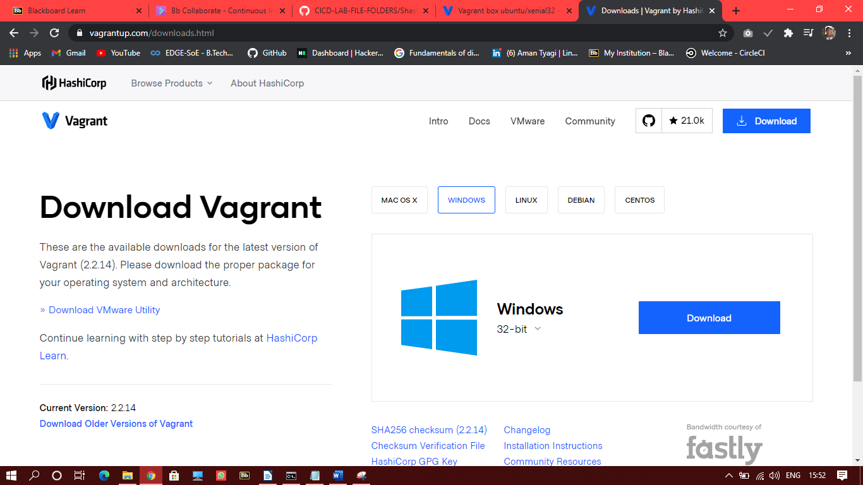

1. Install vagrant and restart your computer and check that vagrant is installed

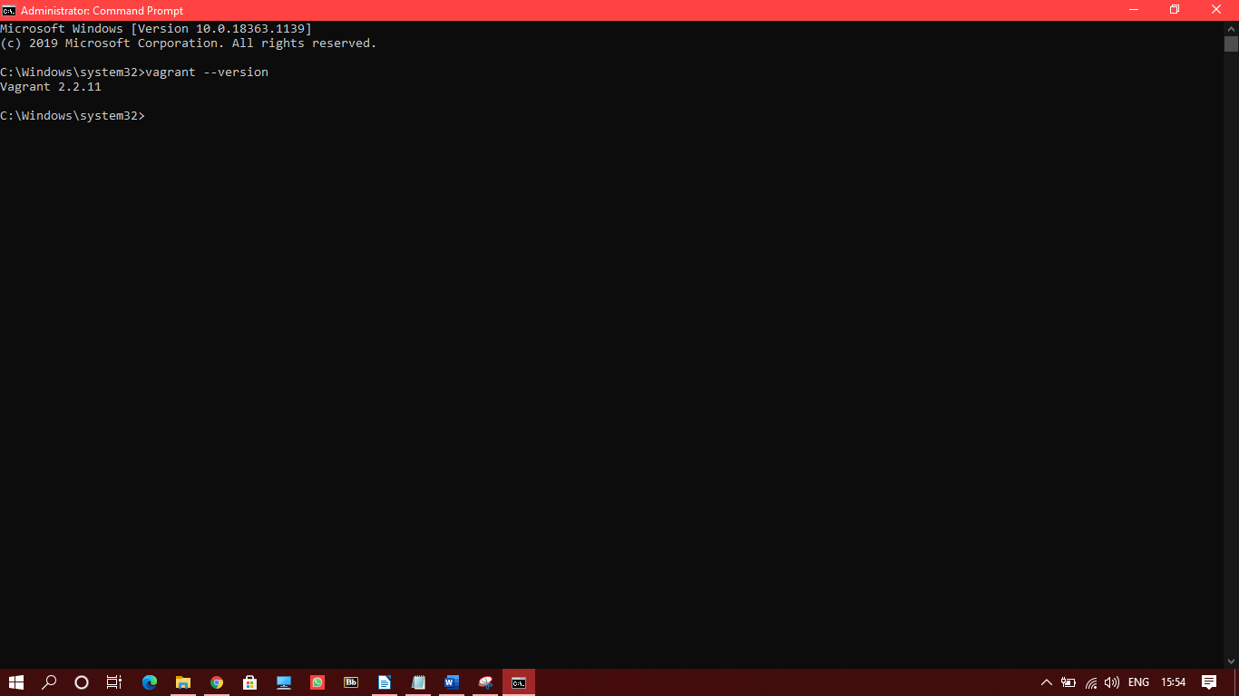

1. Run vagrant init

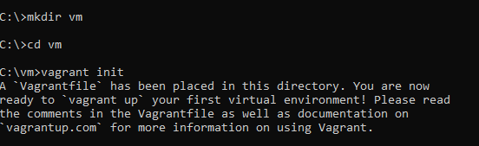

1. Changing the vagrantfile created in the directory

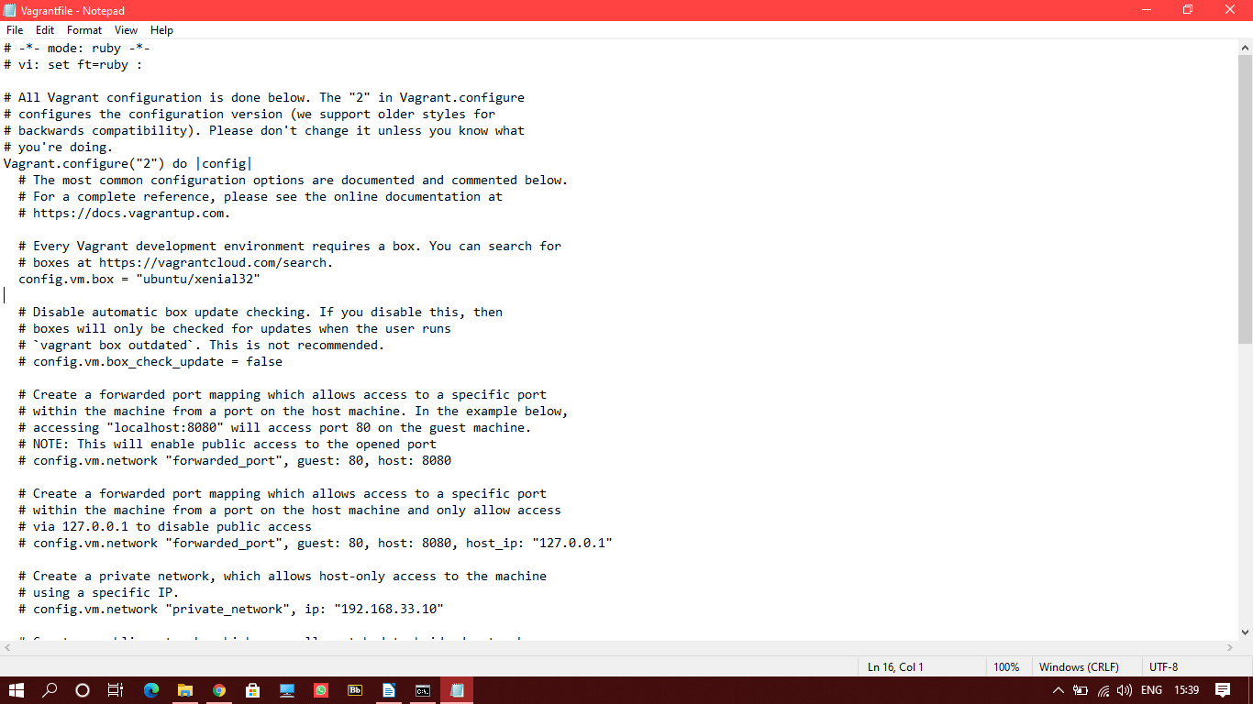

1. Run the ‘vagrant up’ command to create the virtual machine

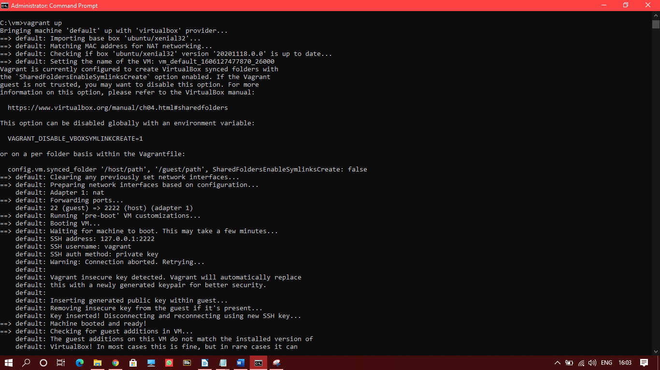

1. Run the ‘vagrant ssh’ command to a attach the ubuntu image created to the windows command line

